

Functional Specification Documentation

Suite8 Interface to SAP B1

Version No.: 2.0
Date: 10th November 2016

Table of Content
1. Overview Details 2
1.1 Objective 2
1.2 Overvew Requirement 2
2. Interface Trial Balance from Suite 8 to SAP 3
3. Statistic Tables 6

1. Overview Details

1.1 Objective

- This program is develop to interface Hotel Grand Pacific front end system Suite 8 into SAP.

1.2 Overvew Requirement

- All the sales capture from suite8 (POS system).

- Abeo will build a program to interface selected data into SAP.

- Below are the defined Information to be interface to SAP:
- Daily Trial Balance (Revenue) – import as Journal Entry in SAP.

- Statistic tables for report purpose
Statistic - Room
      - Table 1 : Occupied Room by Market Segment by day

Statistic – F & B
      - Table 1: F & B Cover Actual
      - Table 2: F & B Cover Budget

- There will be 4 folder created in a specific folder in the server:
Input – Pick suite 8 file from this folder
Success -- to store successful file
Fail –to store failed file
Log – log file

- As long as one of the line item failed, roll back the particular file.

- An email will be send to user

Dear Valued Customer,
Suite8 Interface program had encountered the problem based on the following information.
Please contact your system administrator or Technical consultant to assist you for further information.
Note: This email message is computer generated and it will be used internal purpose usage only.
No | File Name | Status | Error Description
1 | MLyymmdd.csv | Error | Posting period locked; specify an alternative date
2 | RVyymmdd.csv | Error | Code xxx is not defined.
3 | STyymmdd.csv | Succes

2. Interface Trial Balance from Suite 8 to SAP

Pre-requisition:
Below table need to be configure first for Daily Trial Balance Interface

  - Setup Outlet code and Market Segment code as Cost Center in Cost Accounting module in SAP.
  - Suite8 Code GL Mapping (User Defined Table)

Table Name: TBLGLMAP

Suite8Code  (Nvarchar (8)) | CodeName  (Nvarchar (100)) | SAPAcctCode  (Nvarchar (15)) | AcctName  (Nvarchar (100))
1000 | Room Charge | 401001 | Room Revenue
1002 | FO - Day Use | 401102 | Other room revenue - Day use
1003 | FO - Extra Bed - Room Charge | 401103 | Other room revenue - Extra bed
1008 | Room - Service Charge | 401220 | Room service charge receipt
1020 | FO - Room Charge | 401001 | Room Revenue
2014 | F&B - Service Charge INCL | 402220 | F&B service charge receipt
2020 | BF Sun's Cafe Food | 402101 | Food Revenue
2040 | LCH Sun's Cafe Food | 402101 | Food Revenue
2060 | SNA Sun's Cafe Food | 402101 | Food Revenue
2080 | DNR Sun's Cafe Food | 402101 | Food Revenue
2081 | DNR Sun's Cafe Beverage | 402102 | Beverage Revenue
2600 | DNR Room Svc Food | 402101 | Food Revenue
2740 | LCH Banquet Food | 402101 | Food Revenue
2744 | Banquet Meeting Room Rental | 402103 | Other F&B income - Room rental
2791 | FO Rounding | 401001 | Room Revenue
5040 | Telephone Local | 403000 | Tel Revenue
5120 | FO Miscellaneous | 401149 | Other room revenue - Miscellaneous
5500 | Pkg - Breakfast | 402101 | Food Revenue
5511 | BF PKG - Service Charge | 402220 | F&B service charge receipt
950 | US Dollar | 101102 | CashFloat-FrontOffice
953 | Japanese Yen | 101102 | CashFloat-FrontOffice
956 | Australian Dollar | 101102 | CashFloat-FrontOffice
958 | Hong Kong Dollar | 101102 | CashFloat-FrontOffice
8000 | Paid Out | 101102 | CashFloat-FrontOffice
9000 | Cash | 101102 | CashFloat-FrontOffice
9002 | City Ledger | 113001 | AR-CityLedger
9004 | American Express | 113001 | AR-CityLedger
9005 | Visa Card | 113001 | AR-CityLedger
9006 | Master Card | 113001 | AR-CityLedger
9050 | POS - Cash | 101101 | CashFloat-GeneralCashier
9053 | POS - Visa Card | 113001 | AR-CityLedger
9054 | POS - Master Card | 113001 | AR-CityLedger
1010 | 7% GST - Room | 200252 | OuputTax/VAT/GovtTax
2012 | 7% GST INCL - F&B | 200252 | OuputTax/VAT/GovtTax
5045 | 7% GST - TEL | 200252 | OuputTax/VAT/GovtTax
5123 | 7% GST - MISC | 200252 | OuputTax/VAT/GovtTax
5512 | 7% GST - BF PKG | 200252 | OuputTax/VAT/GovtTax

Sample Interface file from Suite 8:

- The Daily Trial Balance will be interface into SAP save as Journal Vourcher and Branch always ‘Hotel’. Select OBTF. BPLId = ‘Hotel’.

- The file format from Suite 8 needs to be in Excel format with below column.
File Name: RVyymmdd.txt or csv (to be confirmed) >> confirmed using csv RVyymmdd.csv
Separator : “;” or “,”(confirmed)

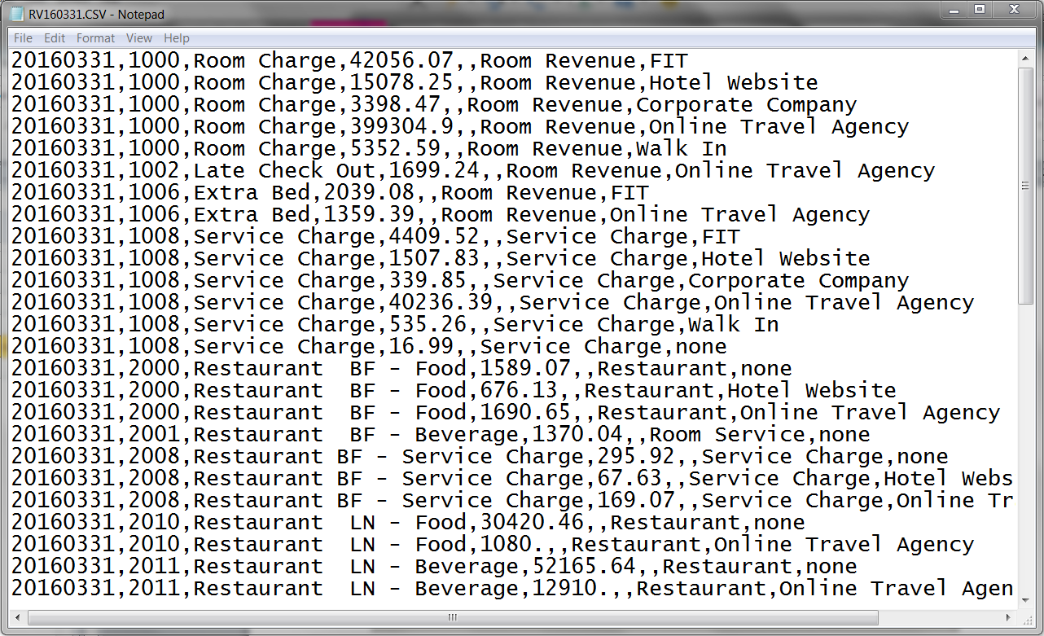

Text File | SAP Field Mapping |  | Requirement
Column 1 | OBTF.RefDate | Posting Date
Column 2 | OBTF.U_SuiteCode | Suite8 Code
 | BTF1.Account | Account Code (SAP | Get SAPAcctCode  from mapping table TBLGLMAP based on Suite8Code ( column 2 in upload template)
Column 3 | OBTF.U_SuiteCode Name | Suite Code Name
Column 4 | BTF1.Debit | Debit
Column 5 | BTF1.Credit | Credit
Column 6 | BTF1.OcrCode3 | Cost Center/Profit Center | Get OrcCode3 based on Column 6 from OPRC.PrcCode where OPRC.DimCode = 3
Column 7 | BTF1.OcrCode4 | Market Segmentation | Get OrcCode4 based on Column 7 from OPRC.PrcCode where OPRC.DimCode = 4

Validation:

1. | Column 2 | SuiteCode not defined in GL mapping table TBLGLMAP.Suite8Code,  Show error message ‘Code xxxx is not defined in the mapping table’.
2. | Column 6 | If Column 6 not found in OPRC.PrcCode where OPRC.DimCode = 3, show error message ‘Code xxxx is not defined’.
3. | Column 7 | If Column 7 not found in OPRC.PrcCode where OPRC.DimCode = 4, show error message ‘Code xxxx is not defined’.

Statistic Tables

Table 1: Occupied Room by Market Segment by day

Sample import file:

File Name: MLyymmdd.txt >> Changed to csv format.
Separator: ‘;’ >> changed to ‘,’

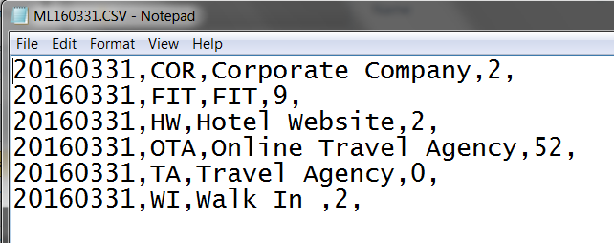

The information will be import to 2 table below in SAP,
@TBLRM = Document header
@TBLRM1 =Document Details
Note: 1 file 1 header entry with multiple row in Document details.

Suite8 Field | SAP Field | Remark
Column 1 | @TBLRM.U_Date | Date
Column 2 | @TBLRM1.U_Code | Market Code
Column 3 | @TBLRM1.U_CodeName | Market Code Name
Column 4 | @TBLRM1.U_Occupied | No of Occupied

Table 2: F & B cover Actual

Sample import file:

File Name: STyymmdd.txt >> changed to csv format
Separator: ‘;’ / ‘,’ (to be confirmed)

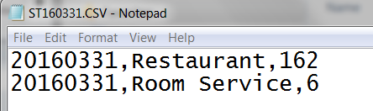

The information will be import to 2 table below in SAP:
@TBFBCA = Document header
@TBFBCA1 =Document Details

Suite8 Field | SAP Field | Remark
Column 1 | @TBFBCA.U_Date | Date
Column 2 | @TBFBCA1.U_Code | Cost Center Name
Column 3 | @TBFBCA1.U_Cover | No of Cover

Table 2: F & B cover Budget (On Hold – to be confirm)

Date | Dim2 | No of cover
09-Jun | Sun café | 2000
09-Jun | Banquet | 1000
 | Room service | 20

The information will be import to 2 table below in SAP:
@TBFBCB = Document header
@TBFBCB1 =Document Details

Suite8 Field | SAP Field | Remark
Date | @TBFBCB.U_Date | Month.
Dim2 | @TBFBCB1.U_Code | No of Occupied
No Of Cover | @TBFBCB1.U_Cover | No of Cover

Table 3: Room Revenue by Market Segment by day

Sample import file:

File Name: MRyymmdd.csv
Separator: “,”

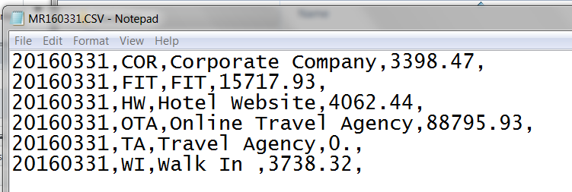

The information will be import to 2 table below in SAP,
@TBLRMV = Document header
@TBLRMV1 =Document Details
Note: 1 file 1 header entry with multiple row in Document details.

Suite8 Field | SAP Field | Remark
Column 1 | @TBLRMV.U_Date | Date
Column 2 | @TBLRMV1.U_Code | Market Code
Column 3 | @TBLRMV1.U_CodeName | Market Code Name
Column 4 | @TBLRMV1.U_Amount | Amount

